Output Screenshot of SQL Assignment4

Output of query1:

Create a stored procedure in the Northwind database that will calculate the average value of Freight for a specified customer.Then, a business rule will be added that will be triggered before every Update and Insert command in the Orders controller,and will use the stored procedure to verify that the Freight does not exceed the average freight. If it does, a message will be displayed and the command will be cancelled.

create proc "calavgfreight of ordertbl"

@custid nvarchar(15)

as

begin

select O.CustomerID,AVG(O.Freight) as "average freight"

from Orders O

where O.CustomerID=@custid

group by O.CustomerID

end

sp_helptext 'insertintoordertbl'

create proc insertintoordertbl2(@OrderID int, @CustomerID nchar(15), @EmployeeID int, @OrderDate datetime, @RequiredDate datetime, @ShippedDate datetime, @ShipVia int, @Freight money, @ShipName nvarchar(50), @ShipAddress nvarchar(60), @ShipCity nvarchar(20), @ShipRegion nvarchar(20), @ShipPostalCode nvarchar(20), @ShipCountry nvarchar(50))

as

begin

declare @avgfraight money

set @avgfraight=(select AVG(Freight) from Orders where CustomerID=@CustomerID)

if(@avgfraight>@Freight)

begin

insert into Orders(OrderID,CustomerID,EmployeeID,OrderDate,RequiredDate,ShippedDate,ShipVia,Freight,ShipName,ShipAddress,ShipCity,ShipRegion,ShipPostalCode,ShipCountry)

values(@OrderID, @CustomerID, @EmployeeID, @OrderDate , @RequiredDate , @ShippedDate , @ShipVia , @Freight , @ShipName, @ShipAddress, @ShipCity, @ShipRegion, @ShipPostalCode, @ShipCountry)

end

else

begin

raiserror ('inserted freight is more than customer avg freight',10,1)

rollback transaction

end

end

set identity_insert Orders on

exec insertintoordertbl2 '10246','VINET','5','','','','1','10','','','','','',''

create proc updateordertbl2(@OrderID int, @CustomerID nchar(15), @EmployeeID int, @OrderDate datetime, @RequiredDate datetime, @ShippedDate datetime, @ShipVia int, @Freight money, @ShipName nvarchar(50), @ShipAddress nvarchar(60), @ShipCity nvarchar(20), @ShipRegion nvarchar(20), @ShipPostalCode nvarchar(20), @ShipCountry nvarchar(50))

as

begin

declare @avgfraight money

set @avgfraight=(select AVG(Freight) from Orders where CustomerID=@CustomerID)

if(@avgfraight>@Freight)

begin

update Orders

set EmployeeID=@EmployeeID,

OrderDate=@OrderDate,

RequiredDate=@RequiredDate,

ShippedDate=@ShippedDate,

ShipVia=@ShipVia,

Freight=@Freight,

ShipName=@ShipName,

ShipAddress=@ShipAddress,

ShipCity=@ShipCity,

ShipRegion=@ShipRegion,

ShipPostalCode=@ShipPostalCode,

ShipCountry=@ShipCountry

where OrderID=@OrderID and CustomerID=@CustomerID

end

else

begin

raiserror('updated freight is more than avg freight',10,1)

rollback transaction

end

end

exec updateordertbl2 '10246','VINET','5','','','','2','10','','','','','',''

select * from Orders

where CustomerID='VINET'

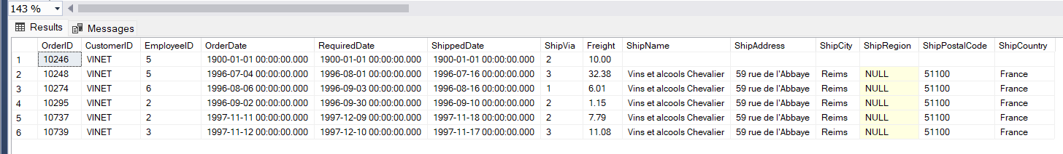

Output of query2:

write a SQL query to Create Stored procedure in the Northwind database to retrieve Employee Sales by Country

create procedure "EmpSalesByCountry"

@Beginningdate DateTime,

@Endingdate DateTime

as

begin

select E.Country,E.LastName,E.FirstName,O.ShippedDate,O.OrderID,SUM(OD.Quantity*OD.UnitPrice) as "Price"

from Employees E

inner join Orders O

on O.EmployeeID=E.EmployeeID

inner join [Order Details] OD

on OD.OrderID=O.OrderID

where O.ShippedDate between @Beginningdate and @Endingdate

group by E.Country,E.FirstName,E.LastName,O.ShippedDate,O.OrderID

end

exec [EmpSalesByCountry] '1996/06/04','1997/06/11'

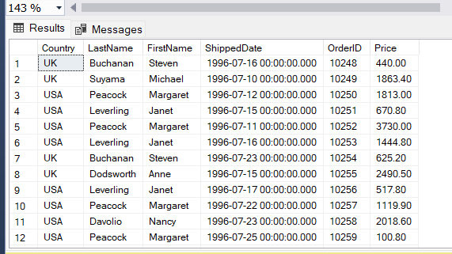

Output of query3:

write a SQL query to Create Stored procedure in the Northwind database to retrieve Sales by Year

create proc "SalesByYear"

@Beginningdate DateTime,

@Endingdate DateTime

as

begin

select O.ShippedDate,O.OrderID,SUM(OD.Quantity*OD.UnitPrice) as "Total",YEAR(O.ShippedDate) as "Year"

from Orders O

inner join [Order Details] OD

on O.OrderID=OD.OrderID

where O.ShippedDate between @Beginningdate and @Endingdate

group by O.ShippedDate,O.OrderID

end

exec [SalesByYear] '1996/09/04','1997/06/11'

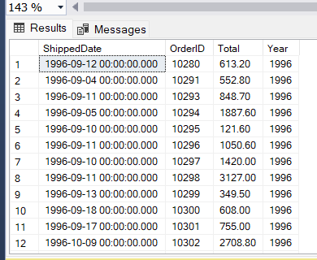

Output of query4:

write a SQL query to Create Stored procedure in the Northwind database to retrieve Sales By Category

create proc "SaleByCategories"

@CategoryName nvarchar(15),

@ordyear nvarchar(4)

as

if @ordyear!='1996'or @ordyear!='1997' or @ordyear!='1998'

begin

declare @msg nvarchar(50)

set @msg='please enter year among 1996,1997,1998'

print @msg

end

select P.ProductName,SUM(P.UnitPrice*OD.Quantity) as "total purchase"

from Products P,[Order Details] OD,Orders O,Categories C

where O.OrderID=OD.OrderID

and P.ProductID=OD.ProductID

and C.CategoryID=P.CategoryID

and C.CategoryName=@CategoryName

group by P.ProductName

order by P.ProductName

exec [SaleByCategories] 'Seafood','2000'

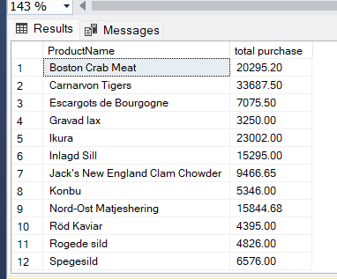

Output of query5:

write a SQL query to Create Stored procedure in the Northwind database to retrieve Ten Most Expensive Products

create proc "Tenmostexpensiveprocs"

as

begin

select top 10 P.ProductName as "Ten most expensive products",P.UnitPrice

from Products P

order by P.UnitPrice desc

end

exec [Tenmostexpensiveprocs]

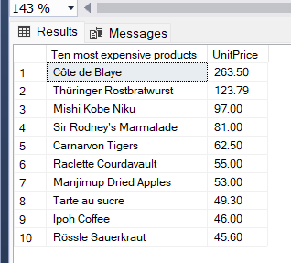

Output of query6:

write a SQL query to Create Stored procedure in the Northwind database to insert Customer Order Details

create proc "insertintoordertbl"

@OrderID int,

@ProductID int,

@UnitPrice money,

@Quantity smallint,

@Discount real

as

begin

insert into [Order Details](OrderID,ProductID,UnitPrice,Quantity,Discount)

values(@OrderID,@ProductID,@UnitPrice,@Quantity,@Discount)

end

exec [insertintoordertbl] '11077','1','25.65','46','0.5'

select * from [Order Details]

where OrderID=11077

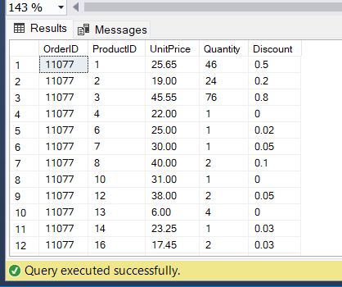

Output of query7:

write a SQL query to Create Stored procedure in the Northwind database to update Customer Order Details

create proc "updateorderdetailtbl"

@OrderID int,

@ProductID int,

@UnitPrice money,

@Quantity smallint,

@Discount real

as

begin

update [Order Details]

set UnitPrice=@UnitPrice,Quantity=@Quantity,Discount=@Discount

where OrderID=@OrderID and ProductID=@ProductID

end

exec [updateorderdetailtbl] '11077','3','45.55','76','0.8'

select * from [Order Details]

where OrderID=11077

